**Assignment 2**

1. **Create a Web page using HTML to demonstrate various CSS selectors including Universal, Type, Grouping (element based), Class, Id, Descendent.**

**Source:**

<!DOCTYPE html>

<html lang="en">

<head>

<meta charset="UTF-8">

<title>Question 1</title>

<style type="text/css">

/* Universal Selector */

* {

background-color: dimgrey;

}

/* ID Selector */

#first_para {

color: lawngreen;

font-size: larger;

font-weight: bold;

}

/* Tag Selector */

hr {

color: azure;

border: 7px solid green;

border-radius: 5px;

margin-left: 30px;

margin-right: 900px;

}

/* Class Selector */

.color_red { color:red; }

/* Descendant Selector */

.parent p {

color: gold;

font-size: small;

}

/* Type Selector */

p {

background: black;

color: lawngreen;

font-size: larger;

}

/* Grouping (element Based) */

h3, h5 {

background: black;

color: fuchsia;

text-align: center;

}

</style>

</head>

<body>

<pre id="first_para">

The Background of the Screen is made to be black using the Universal Selector Property of CSS.

And as for this pre tag, it is enhanced using the ID Selector Property of CSS and is

given a color green and font size as larger and font weight as bold.

</pre>

<br /><br />

<hr />

<br /><br />

<h2 class="color_red">This whole Heading wil be Red to to the CSS Class Selector</h2>

<br /><br/>

<div class="parent">

<p>

The is the Paragraph inside the div with class="parent" and this para is the Descendant

</p>

</div>

<br /><br />

<p>

This Paragraph is for the Demonstration of the Type Selector

</p>

<br /><br />

<h5>This Tag is having the Group Selector Property</h5>

<h3>This Tag also has the Group Selector Property</h3>

</body>

</html>

**Output:**

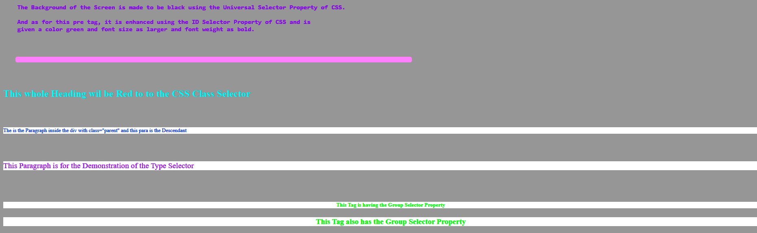

1. **Create a Web page to demonstrate Inline Styles, Embedded Styles and External Stylesheet.**

**CSS Script:**

.extern {

background-color: black;

color: aqua;

font-weight: bolder;

text-align: center;

}

**HTML Script:**

<!DOCTYPE html>

<html lang="en">

<head>

<meta charset="UTF-8">

<title>Question 2</title>

<link rel="stylesheet" type="text/css" href="main.css">

<style type="text/css">

/* This is the Embedded CSS Area */

pre {

background-color: black;

color: chartreuse;

font-size: 20px;

}

</style>

</head>

<body>

<h1 style="text-align: right">This will appear on the Right Side of the Screen due to the Inline CSS Property</h1>

<pre>

This pre tag has taken it's properties from the Embedded CSS in the HTML file

Some other Extra line

</pre>

<div class="extern">

<p>All the contents of this div will have the same attribute and the style given by the external stylesheet</p>

</div>

</body>

</html>

**Output:**

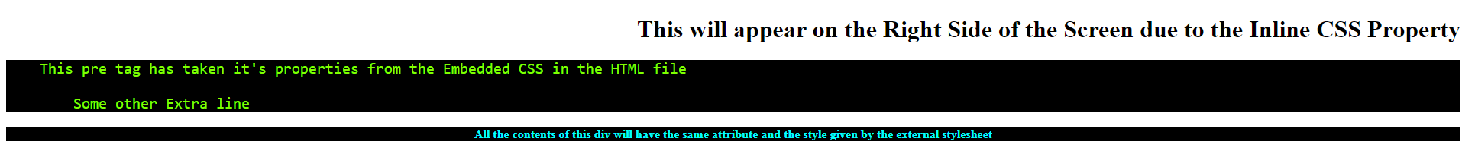

1. **Demonstrate the use of Pseudo Classes in CSS specifically for :hover, :visited, :active, :link and :focus.**

**CSS Script:**

/* Pseudo Classes in CSS */

* {

text-align: center;

}

.box1 {

background-color: yellow;

width: 300px;

height: 100px;

margin: auto;

font-size: 40px;

}

.box2 {

background-color: yellow;

width: 300px;

height: 200px;

margin: auto;

font-size: 40px;

}

.input {

background-color: -moz-default-color;

float: right;

}

h1, h2 {

color: green;

text-align: center;

}

/* :hover class */

.box1:hover {

background-color: orange;

}

/* :visited class */

a:visited {

color: red;

}

/* :active class */

.box2:active {

background-color: aqua;

}

/* :focus class */

input:focus {

background-color: gray;

}

/* :link class */

a:link {

background-color: gold;

}

**HTML Script:**

<!DOCTYPE html>

<html lang="en">

<head>

<meta charset="UTF-8">

<link rel="stylesheet" type="text/css" href="main.css" />

<title>Question 3</title>

</head>

<body>

<h1>CSS Pseudo Classes</h1>

<h2>:hover class</h2>

<div class="box1">The color changes if you Hover!</div>

<br /><br />

<h2>:visited class</h2>

<a href="http://www.google.com" target="_blank">This link will appear in red after being visited</a>

<br /><br />

<h2>:active class</h2>

<div class="box2">The color will change for a moment after clicking</div>

<br /><br/>

<h2>:focus class</h2>

<label for="Username">Username: </label>

<input type="text" name="username" placeholder="Enter the Username">

<br /><br />

<h2>:link class</h2>

<a class="lnk" href="question3.html" target="_blank">A Regular Link</a>

</body>

</html>

**Output:**

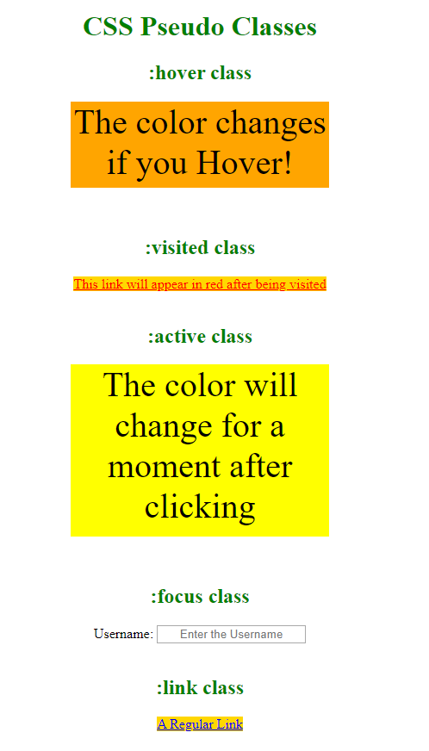

1. **Create a Web page to demonstrate various CSS Properties for Font.**

**CSS Script:**

.font_prop {

font-family: Arial, sans-serif;

font-size: 3vw; /* Due to this the Font Size changes on runtime, instead of getting arranged */

color: deepskyblue;

font-weight: bolder;

font-style: normal;

}

**HTML Script:**

<!DOCTYPE html>

<html lang="en">

<head>

<meta charset="UTF-8">

<link rel="stylesheet" type="text/css" href="main.css">

<title>Question 4</title>

</head>

<body>

<div class="font_prop">All Css Font Properties in one line.</div>

</body>

</html>

**Output:**



1. **Create a Web page to demonstrate various CSS Properties for Text.**

**CSS Script:**

h1 {

letter-spacing: 5px;

color: blue;

text-indent: 35px;

font-size: 20px;

}

h2 {

letter-spacing: 3px;

color: blue;

text-indent: 35px;

font-size: 15px;

}

h4 {

line-height: normal;

color: blue;;

font-size: 15px;

}

h5 {

line-height: 60%;

color: blue;

font-size: 15px;

}

h6 {

line-height: 210%;

color: blue;

font-size: 15px;

}

h7 {

font-size: 15px;

text-transform: uppercase;

color: blue;

text-indent: 35px;

}

h8 {

font-size: 15px;

text-transform: lowercase;

color: blue;

text-indent: 35px;

}

h9 {

font-size: 15px;

text-transform: capitalize;

color: blue;

text-indent: 35px;

}

h10 {

letter-spacing: 25px;

color: blue;

text-indent: 35px;

font-size: 15px;

}

h11 {

letter-spacing: 10px;

color: blue;

text-indent: 35px;

font-size: 15px;

}

h12 {

letter-spacing: -1px;

color: blue;

text-indent: 35px;

font-size: 15px;

}

**HTML Script:**

<!DOCTYPE html>

<html lang="en">

<head>

<meta charset="UTF-8">

<link rel="stylesheet" type="text/css" href="main.css">

<title>Question 5</title>

</head>

<body>

<h1>This paragraph is of 5px letter spacing</h1>

<h2>This paragraph is of 3px letter spacing</h2>

<h3>This paragraph is of -1px letter spacing</h3>

<p><b>Standard/Default Line Height...</b></p>

<h4>

This is a paragraph with standard line-height. <br />

The default height in most browsers is about 110% to 120%.

</h4>

<p><b>Small line-height(60%)</b></p>

<h5>This is a paragraph with smaller line-height.</h5>

<h6>This is a paragraph with bigger line-height</h6>

<br /><br />

<p style="font-size: 20px;">This is the regular text alignment</p>

<br /><br />

<p style="text-align: center;font-size: 20px;">This is the center text alignment</p>

<br /><br />

<p style="text-align: right;font-size: 20px;">This is the right text alignment</p>

<h7>Transformed into uppercase</h7>

<br /><br />

<h8>TRANSFORMED INTO LOWERCASE</h8>

<br /><br />

<h9>transformed into capitalize</h9>

<br /><br />

<h10>This para is 25px letter spacing</h10>

<br /><br />

<h11>This para is 10px letter spacing</h11>

<h12>This para is -1px letter spacing</h12>

</body>

</html>

**Output:**

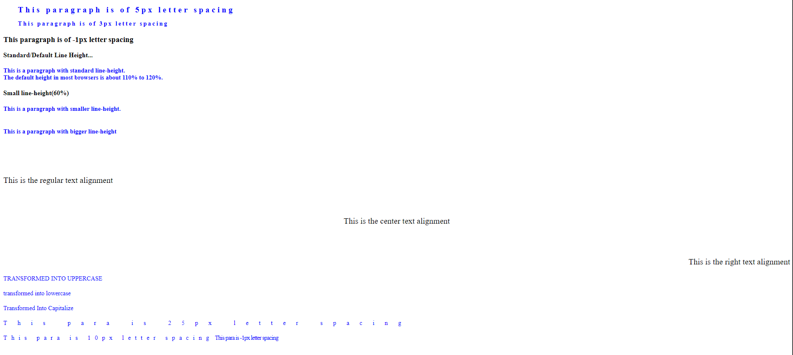

1. **Create a Web page to demonstrate various CSS Properties for background of any element.**

**CSS Script:**

body {

background-image: url("bg.jpg");

}

h1 {

background-color: red;

width: 480px;

background-position: center top;

}

p {

background-color: white;

width: 480px;

font-family: Arial, sans-serif;

}

.demo {

background-color: cyan;

width: 480px;

font-family: Calibri;

}

**HTML Script:**

<!DOCTYPE html>

<html lang="en">

<head>

<meta charset="UTF-8">

<link rel="stylesheet" type="text/css" href="main.css">

<title>Question 6</title>

</head>

<body>

<h1>This is Heading 1</h1>

<br /><br />

<p>A paragraph with edited properties</p>

<br /><br />

<div class="demo">A regular div tag with a CSS Class</div>

</body>

</html>

**Output:**

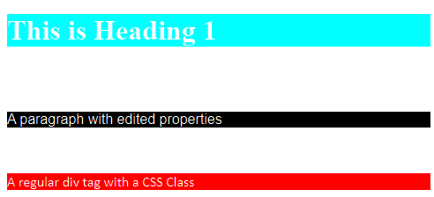

1. **Create a Web page to demonstrate various CSS Properties for border.**

**CSS Script:**

/* DOTTED */

p.dotted {

border-style: dotted;

border-width: 5px;

border-color: red;

}

/* DASHED */

p.dashed {

border-style: dashed;

border-width: medium;

}

/* SOLID */

p.solid {

border-style: solid;

border-width: 2px 10px 4px 20px;

background-color: red green blue yellow;

}

/* DOUBLE */

p.double { border-style: double; }

/* GROOVE */

p.grove { border-style: groove; }

/* RIDGE */

p.ridge { border-style: ridge; }

/* INSET */

p.inset { border-style: inset; }

/* OUTSET */

p.outset { border-style: outset; }

/* NONE */

p.none { border-style: none; }

/* HIDDEN */

p.hidden { order-style: hidden; }

/* MIX */

p.mix { border-style: dotted dashed solid double; }

**HTML Script:**

<!DOCTYPE html>

<html lang="en">

<head>

<meta charset="UTF-8">

<link rel="stylesheet" type="text/css" href="main.css">

<title>Question 7</title>

</head>

<body>

<p class="dotted">A Dotted Border</p>

<p class="dashed">A Dashed Border</p>

<p class="solid">A Solid Border</p>

<p class="double">A Double Border</p>

<p class="groove">A Grooved Border</p>

<p class="ridge">A Ridged Border</p>

<p class="inset">An Inset Border</p>

<p class="outset">An Outset Border</p>

<p class="none">A None Border</p>

<p class="hidden">A Hidden Border</p>

<p class="mix">A Mixed Border</p>

</body>

</html>

**Output:**

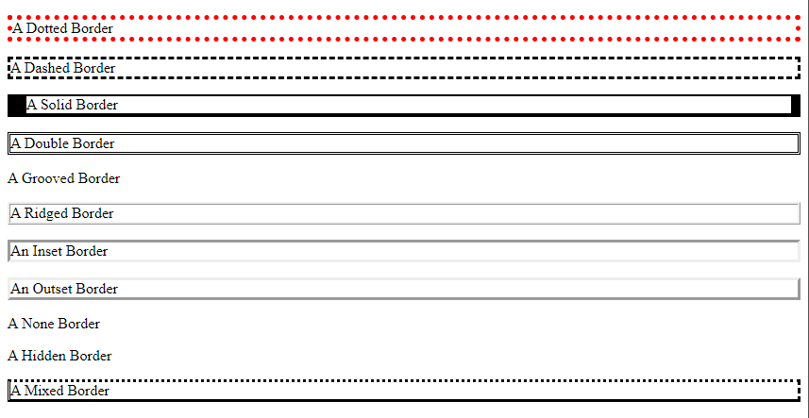

1. **Create a Web page to demonstrate various CSS Properties for Box Model including clear, display, float, height, width, margin, padding.**

**CSS Script:**

.div1 {

text-align: center;

background-color: lightgrey;

width: 300px;

border: 15px solid green;

padding: 25px;

margin: 20px;

height: 200px;

}

.div2 {

border: 1px solid red;

clear: left;

height: 100px;

}

.img1 {

float: left;

display: table;

}

**HTML Script:**

<!DOCTYPE html>

<html lang="en">

<head>

<meta charset="UTF-8">

<link rel="stylesheet" type="text/css" href="main.css">

<title>Question 8</title>

</head>

<body>

<div class="div1">

This is the Text content of the box. An addition of 50px padding, 20px margin and a 15px green border has been made.

<br /><br />

<img class="img1" src="img.jpg" alt="Image Error" width="170" height="100">

</div>

<div class="div2">This Text is the content of the box. A clear left and a border of 1px is added</div>

</body>

</html>

**Output:**

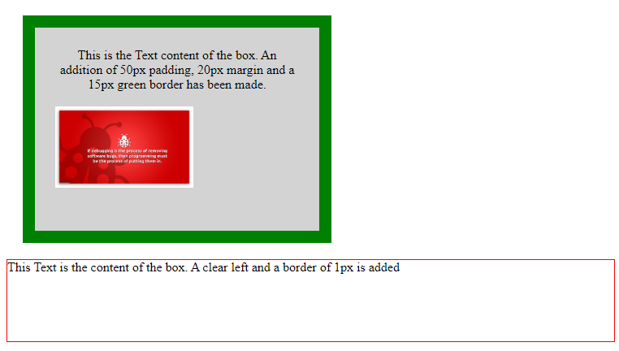

1. **Create a Web page to demonstrate CSS properties for Positioning of an element including bottom, left, position, right, top, z-index.**

**CSS Script:**

div {

border: 3px solid #73ad21;

height: 300px;

width: 500px;

}

img {

position: absolute;

height: 300px;

width: 500px;

z-index: -1;

}

.relative1 {

position: relative;

top: 10px;

left: 2px;

border: 3px solid #73ad21;

width: 150px;

padding: 5px;

}

.relative2 {

position: relative;

bottom: -273px;

left: -145px;

border: 3px solid #73ad21;

width: 150px;

padding: 5px;

}

.relative3 {

position: relative;

top: 10px;

right: -33px;

border: 3px solid #73ad21;

width: 150px;

padding: 5px;

}

.relative4 {

position: relative;

bottom: -255px;

right: -325px;

border: 3px solid #73ad21;

width: 150px;

padding: 5px;

}

.relative5 {

position: relative;

align: center;

top: 110px;

border: 3px solid #73ad21;

width: 150px;

padding: 5px;

}

**HTML Script:**

<!DOCTYPE html>

<html lang="en">

<head>

<meta charset="UTF-8">

<link rel="stylesheet" type="text/css" href="main.css">

<title>Question 9</title>

</head>

<body>

<div>

<img src="bg1.jpg" alt="Image Error">

<span class="relative1">This is the Top Left</span>

<span class="relative2">This is the Bottom Left</span>

<span class="relative3">This is the Top Right</span>

<span class="relative4">This is the Bottom Right</span>

<span class="relative5">This is in the Center</span>

</div>

</body>

</html>

**Output:**

